|  |  |  |  |  |
| --- | --- | --- | --- | --- |
| 1. [taxonomy] ALL | [protein] ALL | [nonmembrane] ALL | [membrane] ALL | [evidence] ALL |

|  |  |  |  |  |
| --- | --- | --- | --- | --- |
| 1. [taxonomy] ALL | [protein] ALL | [nonmembrane] ALL | [membrane] ALL | [evidence] Experimental |

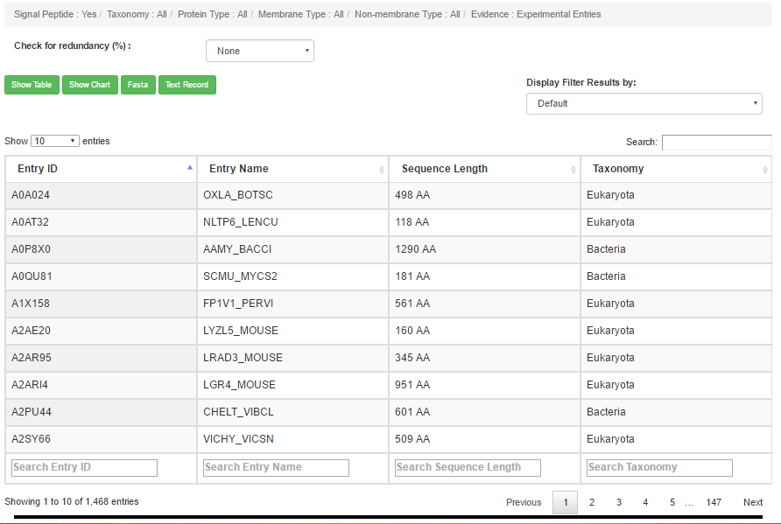

|  |  |  |  |  |
| --- | --- | --- | --- | --- |
| 1. [taxonomy] ALL | [protein] ALL | [nonmembrane] ALL | [membrane] ALL | [evidence] Nonexperimental |

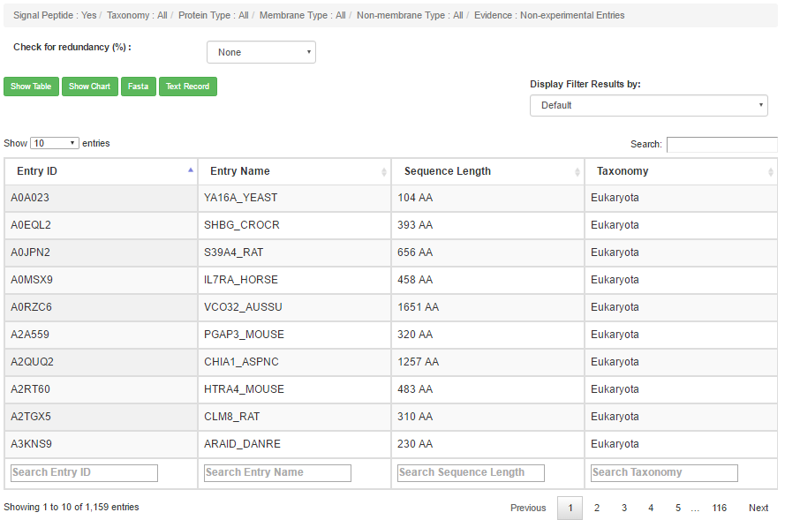

|  |  |  |  |  |
| --- | --- | --- | --- | --- |
| 1. [taxonomy] ALL | [protein] ALL | [nonmembrane] ALL | [membrane] Single-spanning | [evidence] ALL |

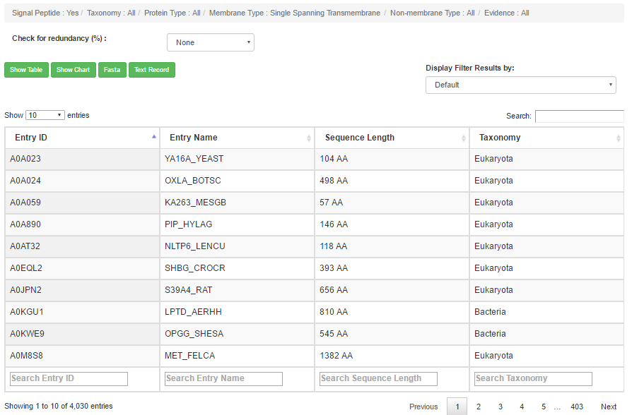

|  |  |  |  |  |
| --- | --- | --- | --- | --- |
| 1. [taxonomy] ALL | [protein] ALL | [nonmembrane] ALL | [membrane] Single-spanning | [evidence] Experimental |

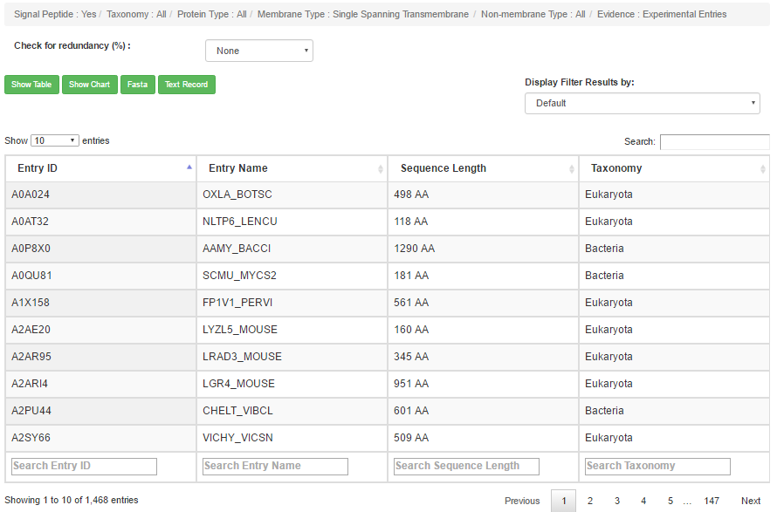

|  |  |  |  |  |
| --- | --- | --- | --- | --- |
| 1. [taxonomy] ALL | [protein] ALL | [nonmembrane] ALL | [membrane] Single-spanning | [evidence] Nonexperimental |

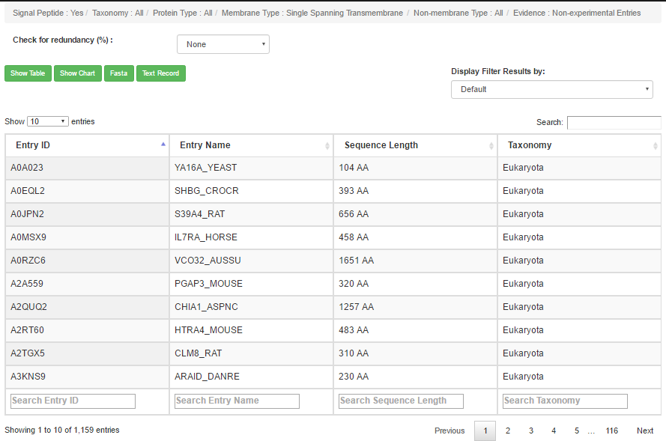

|  |  |  |  |  |
| --- | --- | --- | --- | --- |
| 1. [taxonomy] ALL | [protein] ALL | [nonmembrane] ALL | [membrane] Multi-spanning | [evidence] ALL |
| 8.[taxonomy] ALL | [protein] ALL | [nonmembrane] ALL | [membrane] Multi-spanning | [evidence] Experimental |

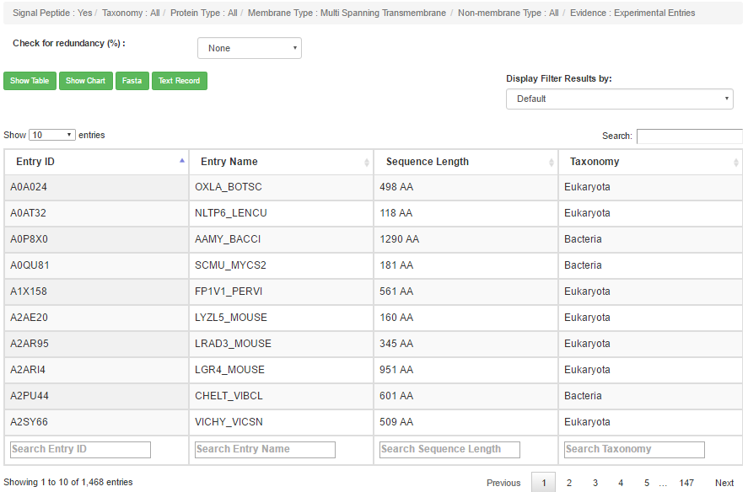

|  |  |  |  |  |
| --- | --- | --- | --- | --- |
| 1. [taxonomy] ALL | [protein] ALL | [nonmembrane] ALL | [membrane] Multi-spanning | [evidence] Nonexperimental |

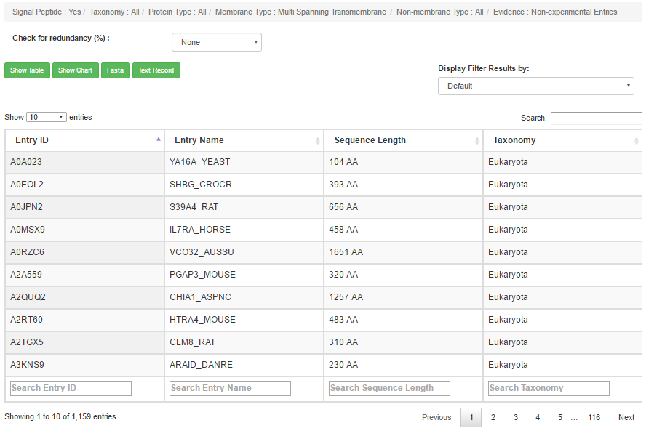

|  |  |  |  |  |
| --- | --- | --- | --- | --- |
| 1. [taxonomy] ALL | [protein] ALL | [nonmembrane] ALL | [membrane] Beta-barrel | [evidence] ALL |
| 1. [taxonomy] ALL | [protein] ALL | [nonmembrane] ALL | [membrane] Beta-barrel | [evidence] Experimental |

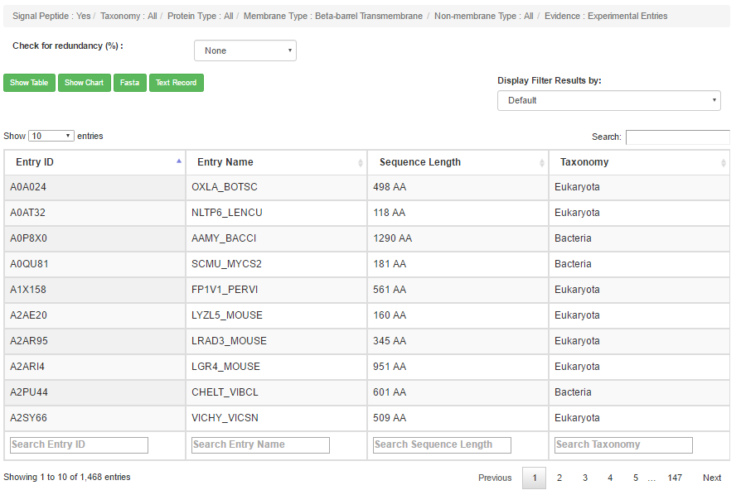

|  |  |  |  |  |
| --- | --- | --- | --- | --- |
| 1. [taxonomy] ALL | [protein] ALL | [nonmembrane] ALL | [membrane] Beta-barrel | [evidence] Nonexperimental |

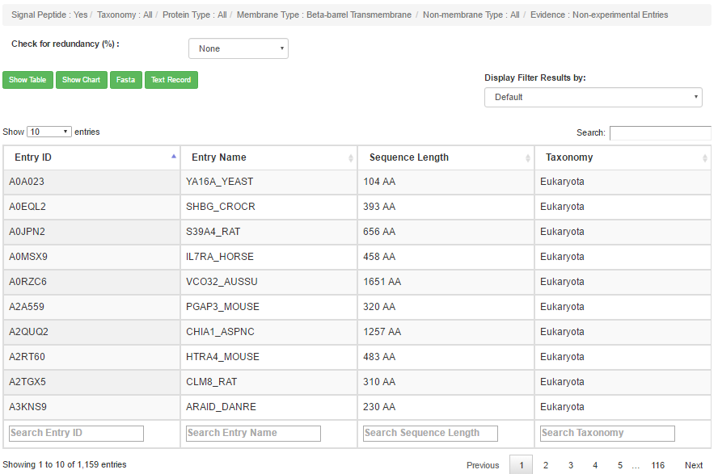

|  |  |  |  |  |
| --- | --- | --- | --- | --- |
| 1. [taxonomy] ALL | [protein] ALL | [nonmembrane] Secretory | [membrane] ALL | [evidence] ALL |

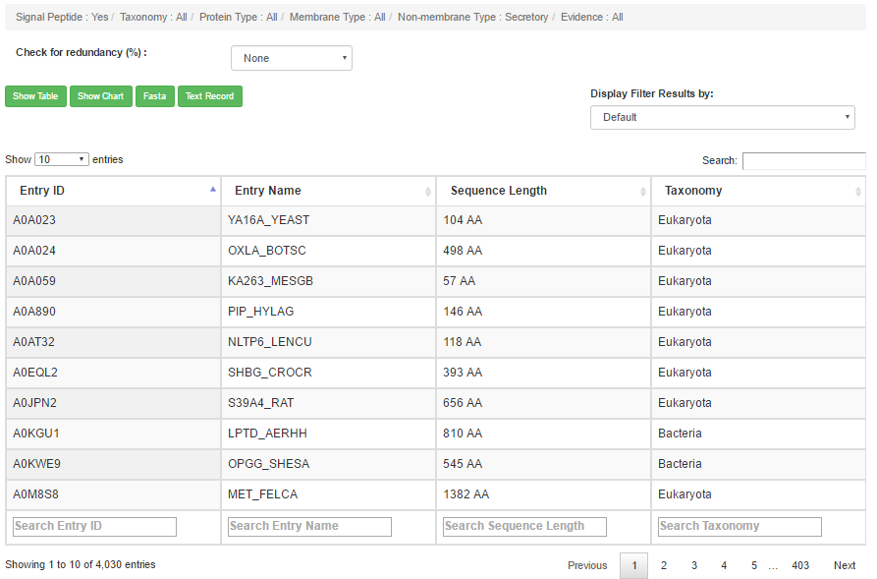

|  |  |  |  |  |
| --- | --- | --- | --- | --- |
| 1. [taxonomy] ALL | [protein] ALL | [nonmembrane] Secretory | [membrane] ALL | [evidence] Experimental |

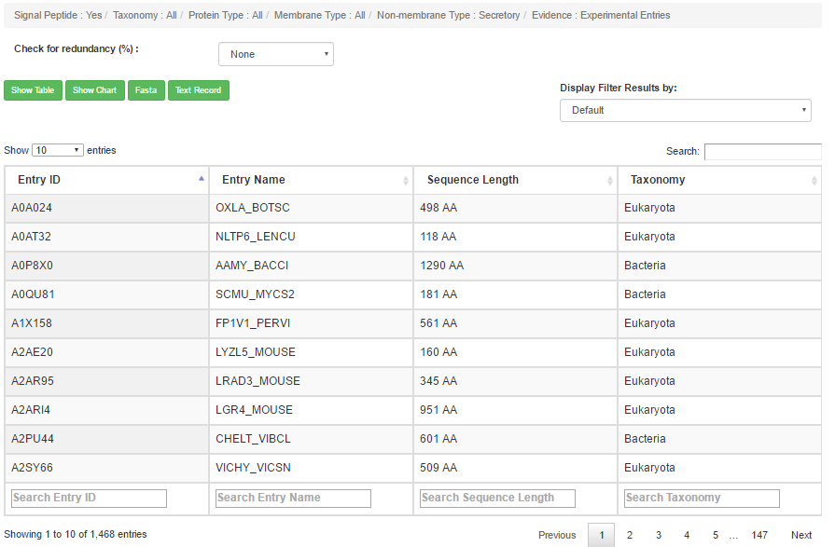

|  |  |  |  |  |
| --- | --- | --- | --- | --- |
| 1. [taxonomy] ALL | [protein] ALL | [nonmembrane] Secretory | [membrane] ALL | [evidence] Nonexperimental |

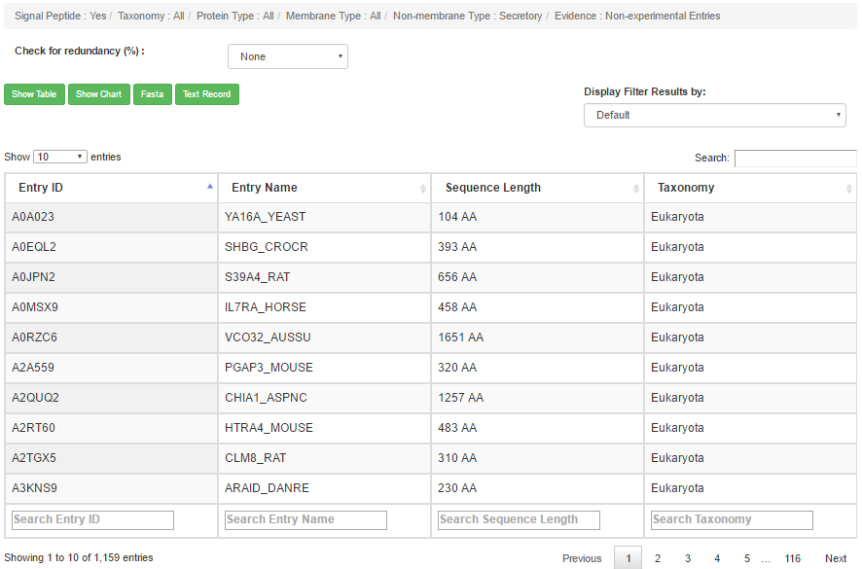

|  |  |  |  |  |
| --- | --- | --- | --- | --- |
| 1. [taxonomy] ALL | [protein] ALL | [nonmembrane] Secretory | [membrane] Single-spanning | [evidence] ALL |

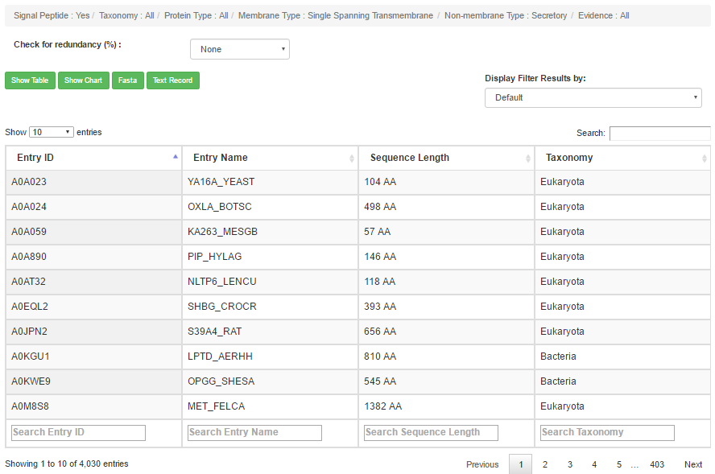

|  |  |  |  |  |
| --- | --- | --- | --- | --- |
| 1. [taxonomy] ALL | [protein] ALL | [nonmembrane] Secretory | [membrane] Single-spanning | [evidence] Experimental |

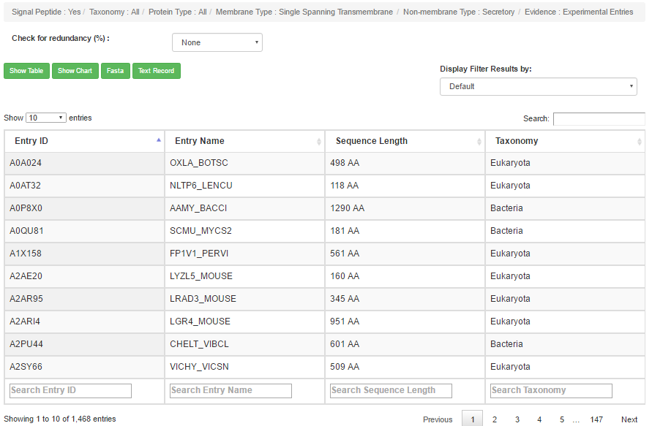

|  |  |  |  |  |
| --- | --- | --- | --- | --- |
| 1. [taxonomy] ALL | [protein] ALL | [nonmembrane] Secretory | [membrane] Single-spanning | [evidence] Nonexperimental |

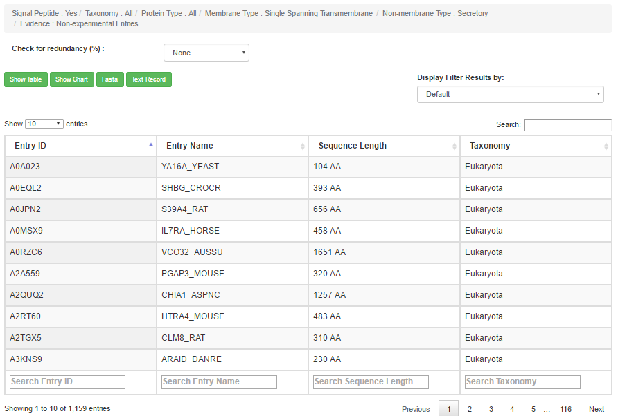

|  |  |  |  |  |
| --- | --- | --- | --- | --- |
| 1. [taxonomy] ALL | [protein] ALL | [nonmembrane] Secretory | [membrane] Multi-spanning | [evidence] ALL |

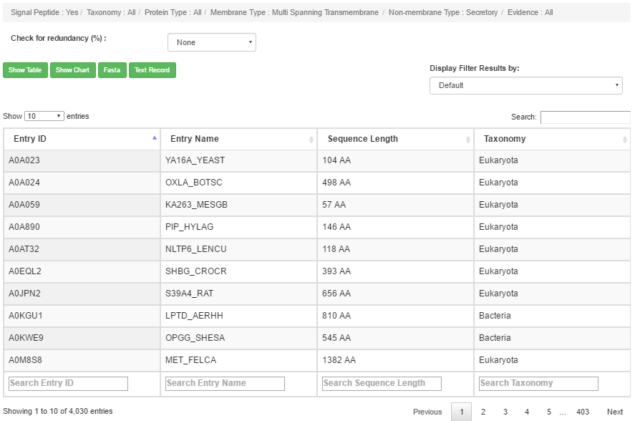

|  |  |  |  |  |
| --- | --- | --- | --- | --- |
| 1. [taxonomy] ALL | [protein] ALL | [nonmembrane] Secretory | [membrane] Multi-spanning | [evidence] Experimental |

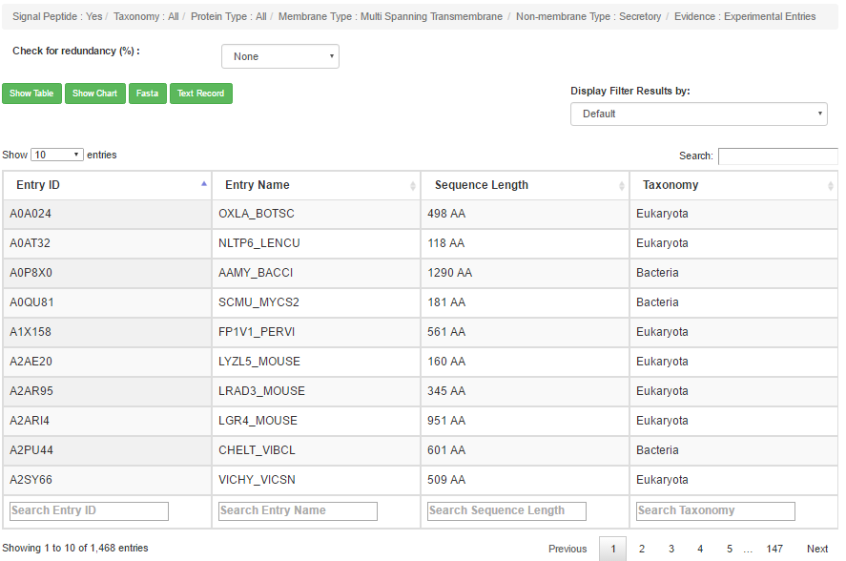

|  |  |  |  |  |
| --- | --- | --- | --- | --- |
| 1. [taxonomy] ALL | [protein] ALL | [nonmembrane] Secretory | [membrane] Multi-spanning | [evidence] Nonexperimental |

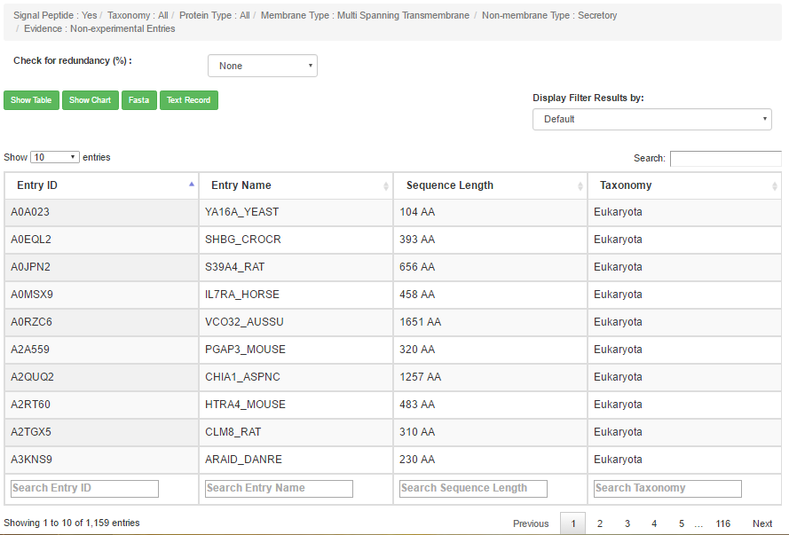

|  |  |  |  |  |
| --- | --- | --- | --- | --- |
| 1. [taxonomy] ALL | [protein] ALL | [nonmembrane] Secretory | [membrane] Beta-barrel | [evidence] ALL |

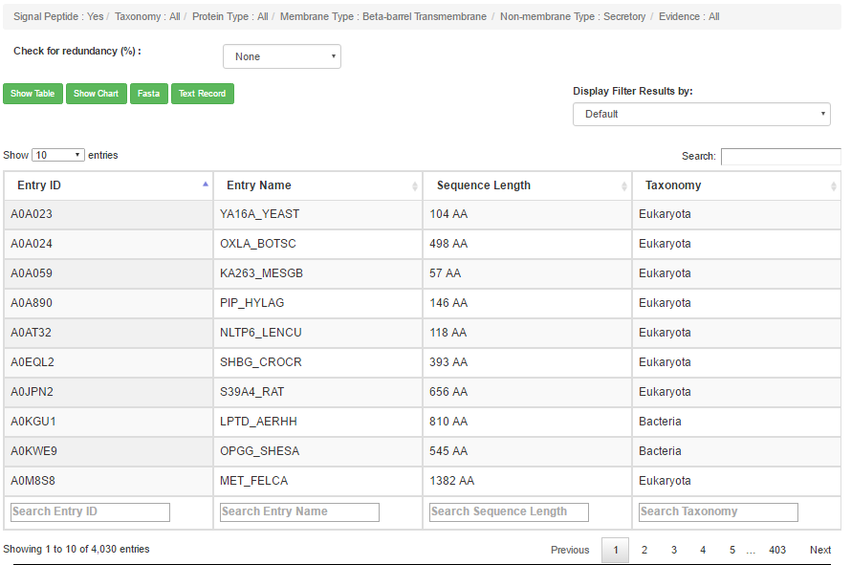

|  |  |  |  |  |
| --- | --- | --- | --- | --- |
| 1. [taxonomy] ALL | [protein] ALL | [nonmembrane] Secretory | [membrane] Beta-barrel | [evidence] Experimental |

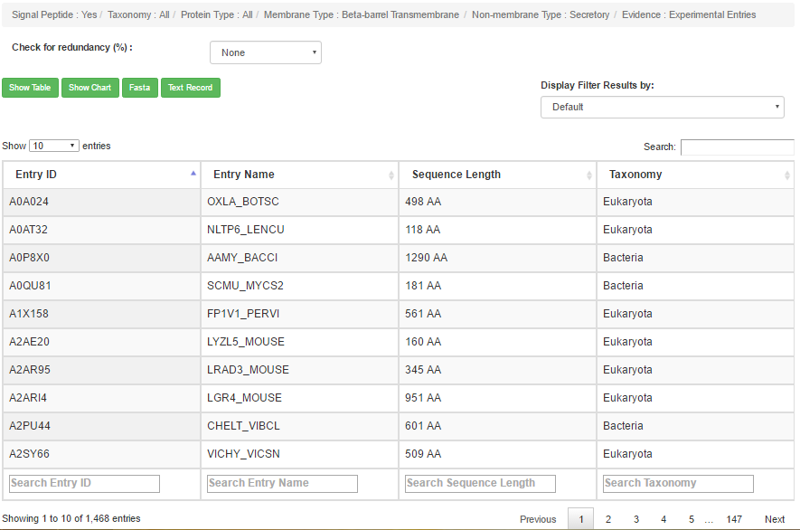

|  |  |  |  |  |
| --- | --- | --- | --- | --- |
| 1. [taxonomy] ALL | [protein] ALL | [nonmembrane] Secretory | [membrane] Beta-barrel | [evidence] Nonexperimental |

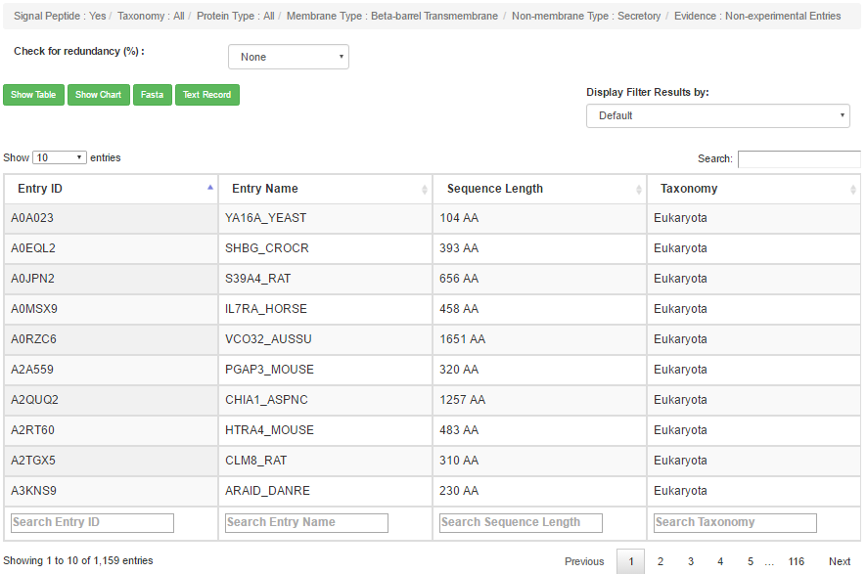

|  |  |  |  |  |
| --- | --- | --- | --- | --- |
| 1. [taxonomy] ALL | [protein] ALL | [nonmembrane] Non-secretory | [membrane] ALL | [evidence] ALL |
| 1. [taxonomy] ALL | [protein] ALL | [nonmembrane] Non-secretory | [membrane] ALL | [evidence] Experimental |

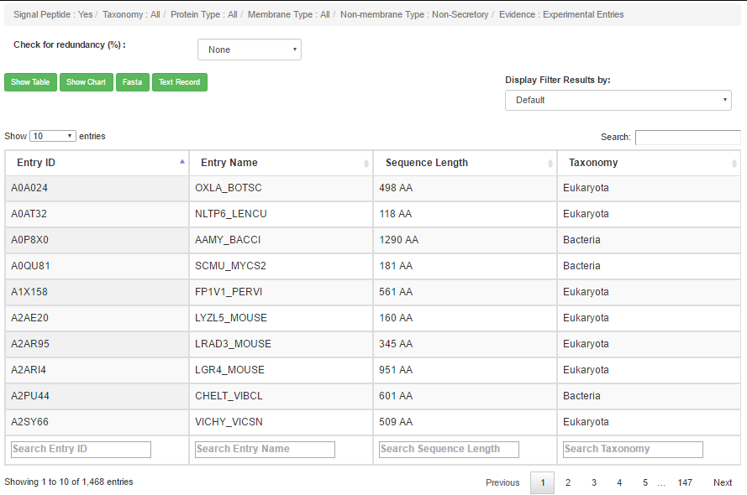

|  |  |  |  |  |
| --- | --- | --- | --- | --- |
| 1. [taxonomy] ALL | [protein] ALL | [nonmembrane] Non-secretory | [membrane] ALL | [evidence] Nonexperimental |

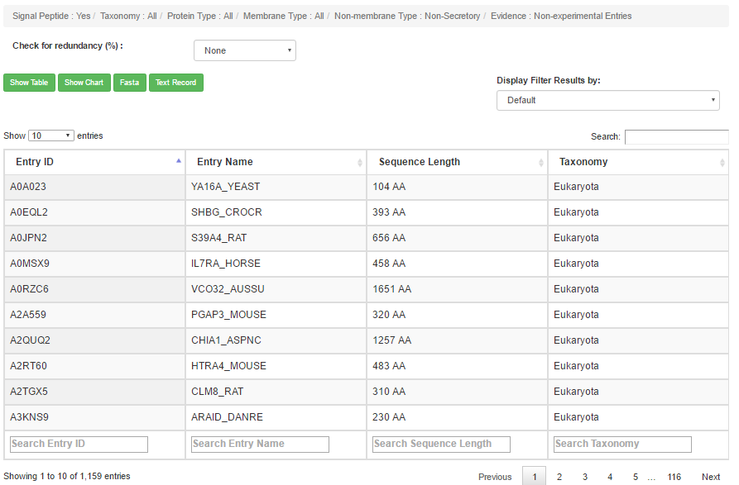

|  |  |  |  |  |
| --- | --- | --- | --- | --- |
| 1. [taxonomy] ALL | [protein] ALL | [nonmembrane] Non-secretory | [membrane] Single-spanning | [evidence] ALL |
| 1. [taxonomy] ALL | [protein] ALL | [nonmembrane] Non-secretory | [membrane] Single-spanning | [evidence] Experimental |

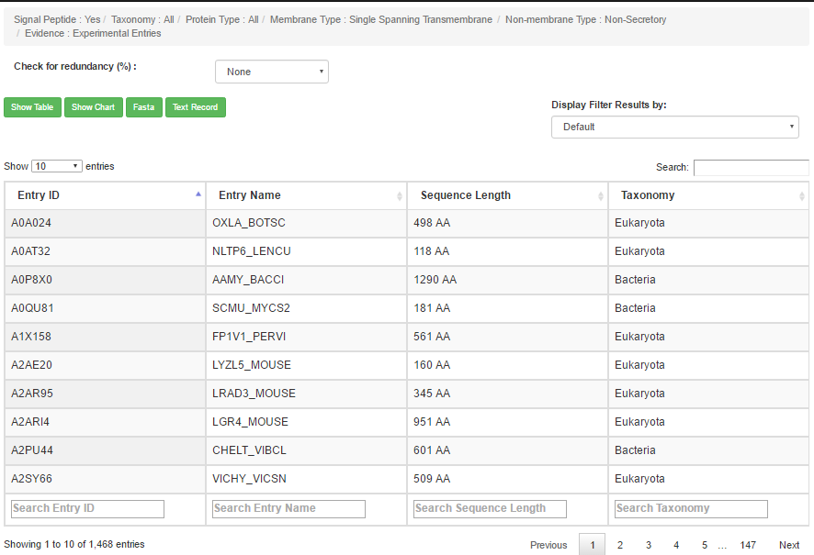

|  |  |  |  |  |
| --- | --- | --- | --- | --- |
| 1. [taxonomy] ALL | [protein] ALL | [nonmembrane] Non-secretory | [membrane] Single-spanning | [evidence] Nonexperimental |

